Using Lego to bridge the skills gap
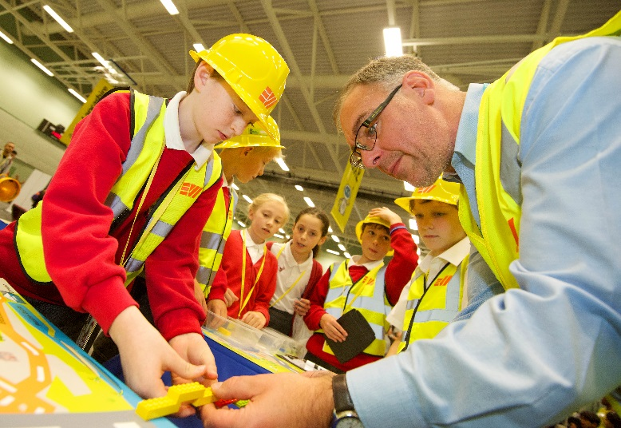
The Lancashire Skills and Employment Hub, part of the Lancashire Enterprise Partnership (LEP) joined forces with partners last weekend at UCLan’s award-winning annual Lancashire Science Festival to promote the City Deal and provide information for young people on career pathways into construction and engineering.
Children visiting the City Deal stand were invited to experience these industries by donning a hard hat and working together to build a model Lego bridge, a representation of a possible new crossing for the River Ribble.
The fair took place over a 3 day period in Preston, from Thursday 30th June to Saturday 2nd July 2016. A partnership of 11 organisations came together through the City Deal Information, Advice and Guidance (IAG) Task Force to develop the stand and run the activities.
Over 660 young people, 175 adults and around 70 schools took part in the City Deal stand's activities. Schools requested that the bridge building exercise be developed into a lesson which could be delivered in schools, this is being developed and will begin in September 2017.
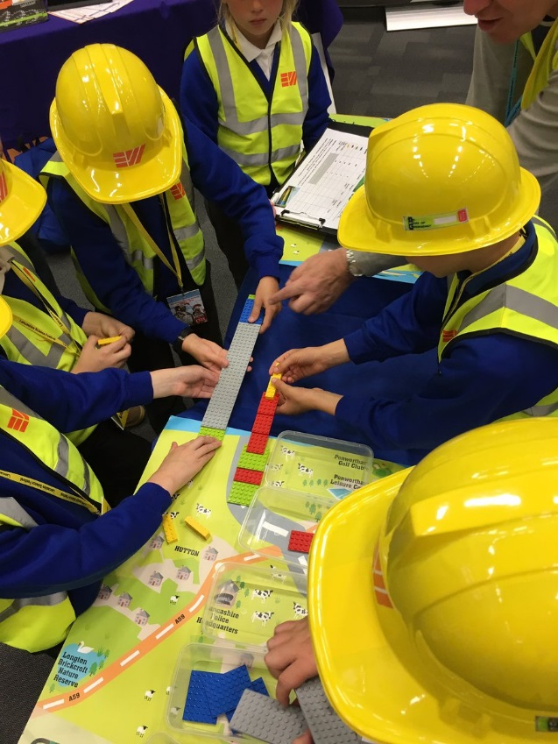
The LEP’s City Deal will transform Preston and Central Lancashire and drive economic growth through the creation of thousands of new jobs and homes - and the infrastructure to support them - over the next decade. The hub is working to increase the skill levels of the county’s workforce in key areas, such as construction and engineering, which will fuel economic growth.
